All about Errors!!!

Below are the set of errors, I came across at the time of running playbook.

**Ansible Playbook Errors …**

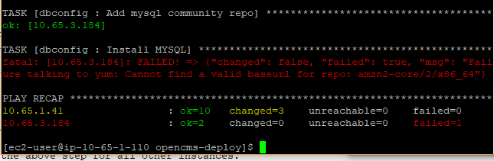

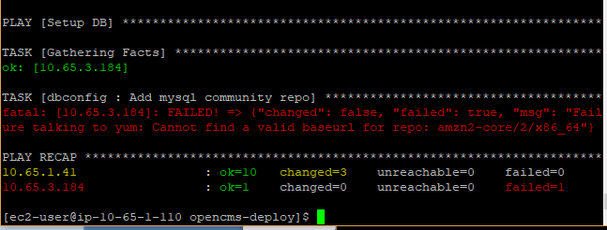

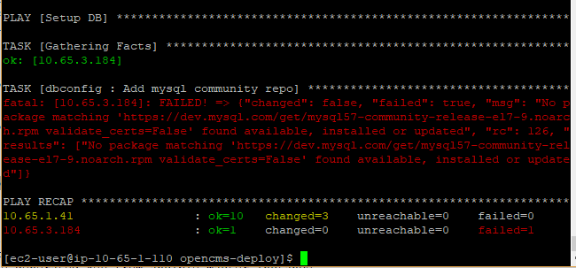

**Manually done , logging into DB01 instance and**

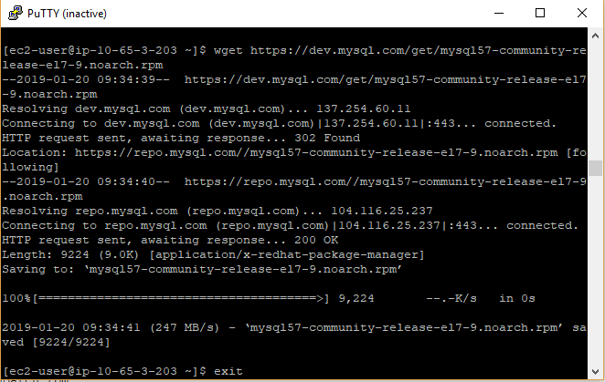

**Error ..**

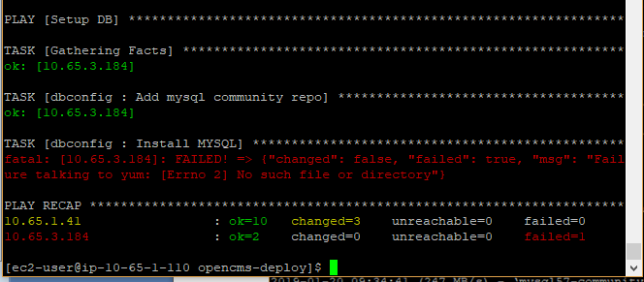

**APPo1 Error :**

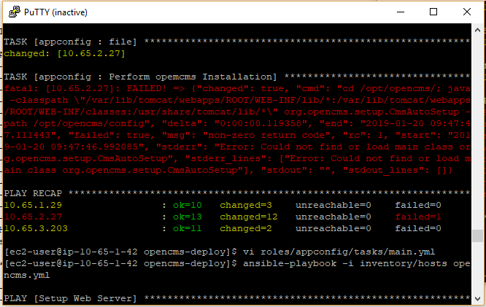

**Manually login into APP01 instance and follow**

**sudo su -**

**java -classpath "/var/lib/tomcat/webapps/ROOT/WEB-INF/lib/*:/var/lib/tomcat/webapps/ROOT/WEB-INF/classes:/usr/share/tomcat/lib/*" org.opencms.setup.CmsAutoSetup -path /opt/opencms/config**

it will take time , approximately 25 Mints

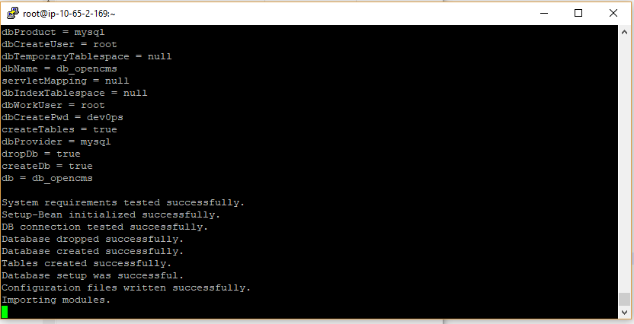

**try connecting to db instance …**

**telnet <DB01 ipaddress> 3306**

**yum install telnet**

